DEMOGRAPHIC INFORMATION Appendix A

SCHOOL ROLL PROJECTIONS 2020-2021 to 2032-2033 REPORT

- Introduction p 2

- Background Information p 2-3

Section 1: Harrow School Roll Projections p 4-5

Section 2: Temporary (‘Bulge’) classes & Permanent Expansions p 6-7

Section 3: School Roll Projections and Need for School Places p 8-39

3.1 Primary Schools
3.2 Data for Reception places 2017/18 in the following tables and charts:
3.3 Projections for Reception to Year 6 Pupils
3.4 Projections for Reception Pupils Only
3.5 Primary Schools Projections by Planning Area
North East Planning Area (GLA Planning Area 1)
North West Planning Area (GLA Planning Area 2)
South East Planning Area (GLA Planning Area 3)
South West Planning Area (GLA Planning Area 4)
Central Planning Area (GLA Planning Area 5)
Faith Schools (GLA Planning Area 6)
3.6 Secondary Schools
3.7 Year 7 Projections for High Schools

Annexes

Annexe 1: Child Population Projections 2020
Annexe 2: Overview of Harrow’s population and changes 2020
Annexe 3: GLA SRP Methodology 2020
Annexe 4: Harrow’s Regeneration programme and Housing Profile 2020
Annexe 5: Affordability of Housing in Harrow v 6.1
Annexe 6: SEND and Early Years Data 2020

- Introduction

A1. The School Roll Projections Report is prepared annually by the Education Team of the Business Intelligence Unit to support the school place planning process in Harrow. The data is analysed to indicate the number of school places required.

A2. The report is produced using a variety of data, including the Greater London Authority’s (GLA) school roll projections to ensure that the number of places available is planned in a timely and measured way so that we can continue to meet our statutory duty to ensure sufficiency of places. Our projections cover the period 2020/21 to 2032/33, helping us to project patterns of demand for school places over this time.

A3. This report provides a summary of the data that informs our work across the next academic year (2020/21) and beyond. The report and associated annexes provide detailed information on projected and actual births, school rolls, expected new residential development and the provision of new places/reduction in provision. There is also high level data identifying demand for special educational needs and for 0-4 year olds for the early years.

A4. This data is provided across the primary and secondary phases of education. Where possible we ensure that changes to Planned Admission Numbers (PAN) in academies, voluntary aided, as well as free schools is incorporated into our planning in a timely manner to enable the local authority to manage the provision of places.

The report has 3 sections:

Section 1: Harrow’s School Roll Projections
Section 2: Temporary (‘Bulge’) classes & Permanent Expansions
Section 3: School Roll Projections and Need for School Places

Six annexes provide background information on:

Annexe 1: Child Population Projections 2020
Annexe 2: Overview of Harrow’s population and changes 2020
Annexe 3: GLA SRP Methodology 2020
Annexe 4: Harrow’s Regeneration programme and Housing Profile 2020
Annexe 5: Affordability of Housing in Harrow v 6.1
Annexe 6: SEND and Early Years Data 2020

- Background information

B1. Demand for school places in London has risen significantly over the past decade, at a faster rate than in any other region of the country. While London has experienced a high demand for primary school places for a number of years , this demand has now shifted to secondary level as pupils reach secondary school age. To manage this, boroughs have been working hard to put plans in place to ensure that the shortfall is met. Some boroughs are focusing on creating new school provision by working with free schools, while others are working to increase the capacity of existing secondary schools.

B2. At the other end of the school system, the total number of surplus places at primary level across London has been rising in recent years. This growth in primary level surplus appears largely to be driven by a decrease in the number of live births across the capital, which decreased by 10 per cent between 2012/13 and 2018/19.

B3. Declining birth rates are also expected to drive primary level surplus over the next four years. For example, between 2020 and 2024, the 0-4 population in London is expected to decrease by 1.0 per cent.

B4. Individual boroughs have also reported other issues such as welfare reform and the uncertainty around Brexit as having an impact on families moving out of the borough.

B5. To manage increasing surplus places at primary level, boroughs are working hard to implement strategies that will help manage capacity and maintain the financial stability of schools.

B6. A range of activity is underway across London to help schools manage surplus places effectively, including transforming primary schools into much needed special schools; reducing the Published Admission Numbers (PAN) for individual schools; redesignating space within or across schools and working with housing developments to change expectations around new schools.

B7. While the overriding trend is towards a growing surplus of places, some boroughs are still grappling with a growing shortfall of places, particularly at secondary level.

B8. There is a complexity of managing secondary school places during a period of growth in demand. It can be hard to forecast the levels of cross border pupil mobility as they fluctuate according to the popularity at different schools, levels of shortfalls or surplus in neighbouring schools, current regeneration and housing developments and changing school admissions policies.

B9. The London Councils 2020 report presents the following key facts:

- London has seen the largest increase in total pupil numbers of any region. Total pupil numbers increased by 13.8 per cent across London between 2010/11 and 2018/19, compared with 8.8 per cent nationally.

- 8,728 new school places are predicted to be needed in 2022/23 to meet demand across London.

- 68 per cent of London’s shortfall of places will be in secondary schools.

- In 2022/23, there will be 84,384 surplus school places across London, which the London boroughs are working hard with schools to manage.

- 84 per cent of the predicted surplus places in 2022/23 will be in primary schools.

Section 1: Harrow School Roll Projections

There is no single accepted method for projecting school numbers and London boroughs have recently faced major challenges in providing places to meet a growing child population. Harrow, along with the majority of other London boroughs, commission’s school roll projections from the Greater London Authority’s (GLA) School Roll Projections Service. The GLA provides the baseline projections to which local knowledge is applied to make reasonable adjustments in line with pressure at Reception, Year 7 and other school year groups.

From 2013 to 2016 we used the GLA’s trend based population school roll projections, informed by in-year applications and admissions. The school roll projections for the Reception year group were adjusted by +3% in 2013 and by +2% in 2014 to reflect local demand. The lower percentage adjustment in 2014 was due to the GLA incorporating additional contextual data for Harrow into their model.

In 2017 the decision was made to continue with the GLA’s Witan trend based population projections based on standard fertility. This was mainly due to the population projections and school roll projections being based on Harrow’s interim 2014-15 housing trajectory, which did not contain all of the known upcoming developments. The decision to use the standard fertility assumption instead of the high fertility was due to the current plateauing of births at the 3.5k mark and is in-line with the lower trend of births in London.

The 2018 school roll projections were based on the 2016 housing-led population projections that incorporate a forecast household development trajectory, using Harrow’s latest housing trajectory.

Last year and this year Harrow’s school roll projections are based on the GLA’s Borough Preferred Option (BPO) Population Projections, which incorporate annual birth, death and migration data. The BPO is produced using Harrow’s ward level housing development data provided by the council from it’s Housing Trajectory. The GLA produced projections based on three different scenarios of domestic migration patterns. The goal was to provide users with suitable variants for use in school place planning work. Harrow has used the Low level variant for Harrow’s births, population projections and school roll projections. Further details of the SRP Methodology can be found in ‘Annexe 3: School Roll Projections Methodology’.

In-line with last year due to the changing landscape of Harrow, with regards to births, future housing developments, Reception and Year 7 numbers on roll, the school organisation report includes two sets of school roll projections:

- The school roll projections as provided by the GLA (referred to as ‘Baseline’ in this report);
- The schools roll projections with a 2% adjustment, as per previous years and in order to maintain some level of consistency.

The local projection methodology has been developed to forecast the maximum numbers that are likely to be on roll at the end of the school year. This approach is consistent with Harrow’s submissions to the DfE and helps with contingency planning across the borough. The in-year growth has tended to take place across the borough rather than in one particular school or planning area. However, should additional forms of entry be needed in any area, contingency plans would be put into action. However, due to the Covid-19 pandemic the DfE cancelled the 2020 School Capacity (SCAP) return.

Section 2: Temporary (‘Bulge’) classes & Permanent Expansions

The number of available Reception places each year since 2009 has been increased in accordance to the rise in demand through the use of temporary ‘bulge’ classes, with permanent expansions implemented from 2013.

Temporary classes are shown in Table 1 below. There were 5 temporary additional ‘bulge’ classes in September 2009, 5 in September 2010, 8 in September 2011 (and a Year 1 class in October 2011 at Camrose Primary School), 12 in September 2012, 9 in September 2013, 10 in September 2014 (and a Year 2 class, a Year 3 class and two Year 4 classes).

In September 2015 two bulge classes were opened in Marlborough Primary School – one in Year 1 and the other vertically across Years 4 and 5, with 15 places in each year group. Since 2015 there have been no additional temporary clasess.

Table 1 - Reception Bulge classes since September 2009
Planning Area | Bulge classes | 2009/10 | 2010/11 | 2011/12 | 2012/13 | 2013/14 | 2014/15
North East Planning Area (PA1) | Aylward |  |  |  |  | 1
North East Planning Area (PA1) | Stanburn |  |  | 1 | 1
North East Planning Area (PA1) | Weald Rise |  | 1 | 1
North East Planning Area (PA1) | Whitchurch |  |  |  |  |  | 1
North West Planning Area (PA2) | Cannon Lane |  |  |  | 1 |  | 1
North West Planning Area (PA2) | Cedars | 1 |  | 1 | 1
North West Planning Area (PA2) | Grimsdyke |  |  |  |  |  | 1
North West Planning Area (PA2) | Longfield |  | 1 |  |  | 1
North West Planning Area (PA2) | Pinner Wood |  | 1 |  |  | 1
South East Planning Area (PA3) | Camrose |  |  |  | 1
South East Planning Area (PA3) | Glebe |  |  | 1 | 1
South East Planning Area (PA3) | Kenmore Park |  | 1 | 1 |  |  | 1
South East Planning Area (PA3) | Priestmead |  |  |  |  |  | 1
South East Planning Area (PA3) | Stag Lane |  |  |  |  |  | 1
South West Planning Area (PA4) | Grange | 1 |  | 1 |  | 1
South West Planning Area (PA4) | Newton Farm |  |  |  |  |  | 1
South West Planning Area (PA4) | Roxeth |  |  |  |  | 1
South West Planning Area (PA4) | Vaughan |  |  |  | 1
South West Planning Area (PA4) | Welldon Park | 1 |  |  | 1
Central Planning Area (PA5) | Belmont | 1 |  |  |  | 1
Central Planning Area (PA5) | Elmgrove |  |  |  | 1 |  | 1
Central Planning Area (PA5) | Marlborough |  |  |  | 1
Central Planning Area (PA5) | Norbury |  | 1 | 1 |  | 1
Central Planning Area (PA5) | Pinner Park |  |  | 1 | 1
Central Planning Area (PA5) | Whitefriars |  |  |  |  |  | 1
Faith Schools (PA6) | St Georges | 1
Faith Schools (PA6) | Avanti House |  |  |  | 2 | 2
Faith Schools (PA6) | St John Fisher |  |  |  |  |  | 1
Total ‘Bulges’ |  | 5 | 5 | 8 | 12 | 9 | 10
Total Places |  | 150 | 150 | 240 | 360 | 270 | 300

Permanent expansions (shown in Table 2 below) have also been implemented, with 8 schools permanently expanding in September 2013, 6 schools from September 2014, 11 schools from September 2015 and 2 schools permanently expanding and 1 new free school opened in 2016. No additional reception classes have been opended since September 2016.

Table 2 - Reception Permanent classes since September 2013
Planning Areas | Permanent classes | 2013/14 – Phase 1 | 2014/15 – Phase 2 | 2015/16 – Phase 3 | 2016/17 – Phase 3
North East Planning Area (PA1) | Aylward |  | 1
North East Planning Area (PA1) | Stanburn | 1
North East Planning Area (PA1) | Weald Rise |  |  |  | 1
North East Planning Area (PA1) | Whitchurch |  |  | 1
North West Planning Area (PA2) | Cannon Lane |  |  | 1
North West Planning Area (PA2) | Cedars | 1
North West Planning Area (PA2) | Grimsdyke |  |  | 1
North West Planning Area (PA2) | Longfield |  |  | 1
North West Planning Area (PA2) | Pinner Wood |  | 1
South East Planning Area (PA3) | Camrose | 1
South East Planning Area (PA3) | Glebe | 1
South East Planning Area (PA3) | Kenmore Park |  |  | 1
South East Planning Area (PA3) | Priestmead |  |  | 1
South East Planning Area (PA3) | Stag Lane |  |  |  | 1
South West Planning Area (PA4) | Grange |  | 1
South West Planning Area (PA4) | Newton Farm |  |  | 1
South West Planning Area (PA4) | Vaughan | 1
South West Planning Area (PA4) | Welldon Park |  |  | 1
Central Planning Area (PA5) | Belmont |  | 1
Central Planning Area (PA5) | Elmgrove |  |  | 1
Central Planning Area (PA5) | Marlborough | 1
Central Planning Area (PA5) | Norbury |  | 1
Central Planning Area (PA5) | Pinner Park | 1
Central Planning Area (PA5) | Whitefriars |  |  | 1
Faith Schools (PA6) | Avanti House |  | 2
Faith Schools (PA6) | Krishna Avanti | 1
Faith Schools (PA6) | St John Fisher |  |  | 1
Faith Schools (PA6) | St Jérôme |  |  |  | 2
Total Classes |  | 8 | 7 | 11 | 4
Total Places |  | 240 | 210 | 330 | 120
Section 3: School Roll Projections

School place planning for Harrow’s primary and secondary schools for 2020-21 is based on the GLA’s school roll projections, which are based on the GLA’s 2018-based Housing-led Borough Preferred Option Population Projections.

3.1 Primary Schools
Information on primary school roll projections is divided into three parts:

- Projections for all Reception to Year 6 pupils.

- Projections for all Reception pupils only.

- Primary Schools Projections by Planning Areas:
a) Reception to Year 6 pupils, and
b) Reception pupils

Harrow’s Planning Areas will be reviewed following the Governments review of local authority ward boundary changes in May 2022.

3.2 Data for Reception places 2020-21 in the following tables and charts
The 2020-21 school roll projections are based on the GLA’s 3/1 option, which uses:

- three years of past detailed flow data (2017-2019) to define relationships between ward of residence and school attended for the 2020 roll
- one year of school-level rolls (2020) to calculate the size of the new intake.
This setup aims to smooth fluctuations in the underlying patterns of pupil movement, while reflecting only the most recent data in terms of overall number of pupils on roll.

The actual Reception numbers on roll reached an all time high of 3,251 in January 2015; however the numbers dropped to 3,195 in January 2016 and then again to 3,154 in January 2017 but rose slightly to 3,189 in January 2018, then dropped to 3,043 in January 2019 but rose slightly by 35 children to 3,079 in January 2020. Due to these fluctuations and change in trajectory we have continued to include two sets of school roll projections for the borough total projections for Reception to Year 6, and Reception only:

- The GLA’s actual (referred to as Baseline) school roll projections
- The GLA’s school roll projections adjusted by 2%.

The GLA projections indicate that 3,182 (Baseline) and 3,246 (+2%) children would require Reception places by January of the academic year 2020-21.

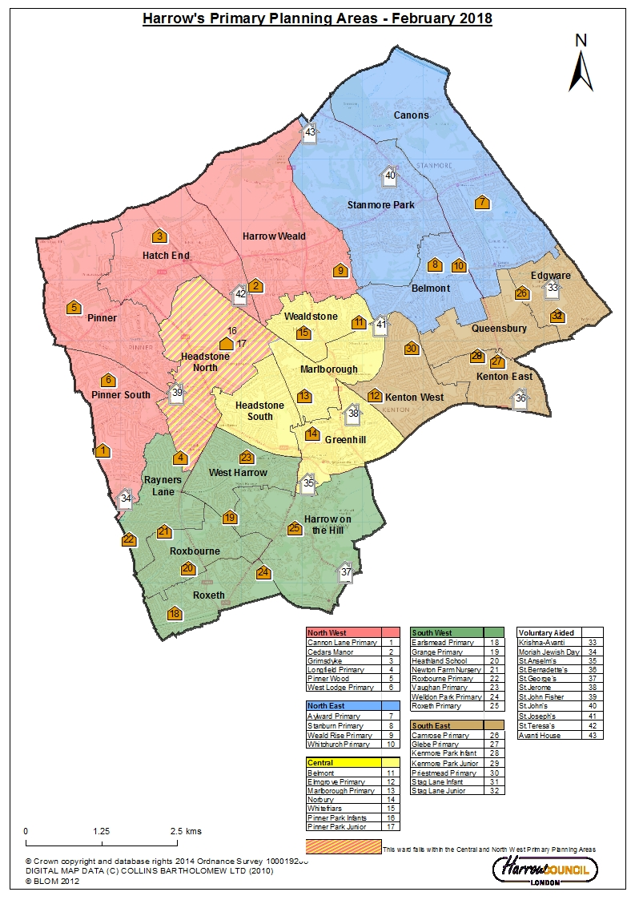
Map is correct as of Feb 2018 but does not relect the changes at Pinner park and Stag lane
3.3 Projections for Reception to Year 6 Pupils

Pupil numbers have been fluctuating across all of the primary phase year groups, from Reception to Year 6.

Based on the 2020/21 round of GLA school roll projections, the information in Table 3 and Chart 1 below shows that the number of pupils in Reception to Year 6 are projected to fluctuate over the period covered, with some increase and decrease.

The data in the table below shows that the number of children in Harrow’s primary schools has increased by 71 (0.3%) children from 21,643 in 2018/19 to 21,714 in 2019/20. Whilst Harrow’s primary schools have had a deficit of school places in Reception to Year 6 in 2013/14 and 2014/15, there has been a surplus of places in recent years, from 236 extra places in 2015/16 to 614 in 2016/17, 1,049 extra places in 2017/18, 1,367 places in 2018/19 and 1,746 places in 2019/20. The projections are suggesting even higher surplus places, from 2,099 (Baseline) and 2,035 (+2%) in 2020/21 to 905 (Baseline) and 839 (+2%) by 2032/33. The surplus places are calculated from the projected pupil numbers and the places available.

Table 3: School roll projections for Year Reception (Baseline & +2%) to Year 6 in all schools in Harrow
Primary projection area: All Schools - DCLG Low 3-1
Years R to 6 only
Year | January actual number on roll | Projected demand GLA (Baseline Reception) | Projected demand GLA (+2% Reception) | Places available | Surplus/Deficit of places (Baseline Reception) | Surplus/Deficit of places +2% Reception)
08/09 | 16,637 |  |  | 18,139 | 1,502
09/10 | 16,920 |  |  | 18,155 | 1,235
10/11 | 17,326 |  |  | 18,187 | 861
11/12 | 17,860 |  |  | 18,439 | 579
12/13 | 18,482 |  |  | 18,718 | 236
13/14 | 19,325 |  |  | 19,278 | -47
14/15 | 20,158 |  |  | 20,152 | -6
15/16 | 20,760 |  |  | 20,996 | 236
16/17 | 21,136 |  |  | 21,750 | 614
17/18 | 21,346 |  |  | 22,395 | 1,049
18/19 | 21,643 |  |  | 23,010 | 1,367
19/20 | 21,714 |  |  | 23,460 | 1,746
20/21 |  | 21,691 | 21,755 | 23,790 | 2099 | 2035
21/22 |  | 21,676 | 21,740 | 23,760 | 2084 | 2020
22/23 |  | 21,654 | 21,719 | 23,730 | 2076 | 2011
23/24 |  | 21,631 | 21,694 | 23,580 | 1949 | 1886
24/25 |  | 21,645 | 21,707 | 23,430 | 1785 | 1723
25/26 |  | 21,930 | 21,993 | 23,280 | 1350 | 1287
26/27 |  | 22,159 | 22,223 | 23,190 | 1031 | 967
27/28 |  | 22,143 | 22,207 | 23,100 | 957 | 893
28/29 |  | 22,069 | 22,133 | 23,100 | 1031 | 967
29/30 |  | 22,026 | 22,091 | 23,100 | 1074 | 1009
30/31 |  | 22,053 | 22,118 | 23,100 | 1047 | 982
31/32 |  | 22,126 | 22,192 | 23,100 | 974 | 908
32/33 |  | 22,195 | 22,261 | 23,100 | 905 | 839
Source: SRP_borough_Spring2020_3_1_BPO2018_lowDomMig_2904201447

The ‘Places available’ figure for 2009/10 to 2014/15 includes the actual increased Published Admission Numbers (PAN) and bulge classes; and for 2015/16 and 2016/17 planned permanent increases to PANs and St Jérôme Bilingual School, which opened in September 2016.

Chart 1: Current number on roll compared to roll projections and places available for Year Reception (Baseline) to Year 6 in all schools in Harrow
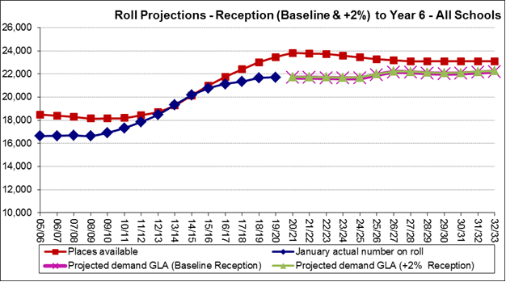
Source: SRP_borough_Spring2020_3_1_BPO2018_lowDomMig_2904201447

3.4 Projections for Reception Pupils Only

Reception numbers increased from 2,224 in January 2006 to 3,251 in January 2015; this is a 46% increase. Reception numbers dropped in January 2016 to 3,195 and in January 2017 to 3,154, and then they increased slightly by 39 pupils in 2017/18, however they dropped quite significantly in 2018-19 by 146 to 3,043 but increased slightly in 2019/20 by 36 to 3,079. The GLA Baseline and +2% projections are shown in Table 4 below, with the baseline projection of 3,182 pupils and the +2% adjusted projection of 3,246 in 2020/21. There is some fluctuation in the projections but overall remain reasonably steady over the 2020/21 to 2032/33 period, as can be seen in table 4 and the chart below.

School Expansion Programme Phase 1
The number of Harrow’s Reception permanent places increased by 240 places to 2,790 in September 2013 following implementation of Phase 1 of the Primary School Expansion Programme. 7 community schools were expanded permanently along with the expansion by one form of entry of Krishna Avanti Primary School to become a 2 form of entry academy school. 9 temporary Reception classes brought total places in 2013/14 to 3,060.

School Expansion Programme Phase 2
In September 2014, Harrow’s Reception permanent places were increased by 210 places to 3,000 following implementation of the first group of Phase 2 of the Primary School Expansion Programme (this includes two forms of entry at Avanti House free school). In order to meet the full increased demand for Reception places, 10 bulge classes (300 places) were opened at schools. In September 2015, Harrow’s Reception permanent places were increased by 330 permanent places in 11 schools following the full implementation of Phase 2 and the first permanent expansions in Phase 3.

Table 4: School roll projections for Year Reception (Baseline & +2%) in all Primary schools in Harrow
Primary projection area: All Schools
Year Reception
School Year | January actual number on roll | GLA projected demand Baseline | GLA projected demand +2% | Reception Places available | Permanent Places | Calculated FE Baseline | Calculated FE +2% | Additional FE required  Baseline & +2% | Total Reception Places required to meet  Baseline & +2%
08/09 | 2,419 |  |  | 2,530 | 2,530
09/10 | 2,571 |  |  | 2,696 | 2,546
10/11 | 2,637 |  |  | 2,700 | 2,550
11/12 | 2,759 |  |  | 2,800 | 2,550
12/13 | 2,879 |  |  | 2,910 | 2,550
13/14 | 3,029 |  |  | 3,060 | 2,790
14/15 | 3,251 |  |  | 3,300 | 3,000
15/16 | 3,195 |  |  | 3,330 | 3,330
16/17 | 3,154 |  |  | 3,450 | 3,450
17/18 | 3,189 |  |  | 3,450 | 3,450
18/19 | 3,043 |  |  | 3,450 | 3,450
19/20 | 3,079 |  |  | 3,390 | 3,450
20/21 |  | 3,182 | 3,246 | 3,390 | 3,450 | 6.93 | 4.81 | 0 | 3,390
21/22 |  | 3,196 | 3,260 | 3,300 | 3,450 | 3.47 | 1.34 | 0 | 3,300
22/23 |  | 3,249 | 3,314 | 3,300 | 3,450 | 1.70 | -0.47 | 0 | 3,300
23/24 |  | 3,133 | 3,196 | 3,300 | 3,450 | 5.57 | 3.48 | 0 | 3,300
24/25 |  | 3,105 | 3,167 | 3,300 | 3,450 | 6.50 | 4.43 | 0 | 3,300
25/26 |  | 3,158 | 3,221 | 3,300 | 3,450 | 4.73 | 2.63 | 0 | 3,300
26/27 |  | 3,205 | 3,269 | 3,300 | 3,450 | 3.17 | 1.03 | 0 | 3,300
27/28 |  | 3,205 | 3,269 | 3,300 | 3,450 | 3.17 | 1.03 | 0 | 3,300
28/29 |  | 3,211 | 3,275 | 3,300 | 3,450 | 2.97 | 0.83 | 0 | 3,300
29/30 |  | 3,240 | 3,305 | 3,300 | 3,450 | 2.00 | -0.16 | 0 | 3,300
30/31 |  | 3,268 | 3,333 | 3,300 | 3,450 | 1.07 | -1.11 | 1 | 3,330
31/32 |  | 3,290 | 3,356 | 3,300 | 3,450 | 0.33 | -1.86 | 2 | 3,360
32/33 |  | 3,295 | 3,361 | 3,300 | 3,450 | 0.17 | -2.03 | 2 | 3,360
Source: SRP_borough_Spring2020_3_1_BPO2018_lowDomMig_2904201447

*Places available 2009/10, 2010/11, 2011/12, 2012/13, 2013/14, 2014/15, 2015/16 and 2016/17 include actual increased PANs and bulge classes, as well as St Jérôme’s bilingual school that opened in September 2016;

**There has been a formal reduction in the PANs of Cedars Manor & Welldon Park Academy School’s, from 3FE to 2FE, and Weald Rise Primary School’s PAN has been reduced from 4FE to 2FE from 2020/21.

A formal reduction of places for 2021/22 has been agreed for the following schools: Kenmore Park (4FE to 3FE); Longfield Primary (4FE to 3FE) and Roxbourne Primary (3FE to 2FE).

There are an additonal 60 places at Hujjat Primary from September 2020, these have been included in the table above.

It should be noted that although a some of the primary planning areas in section 3.5 below are projecting a deficit in Reception places, Table 4 above clearly indicates that Harrow has a sufficient number of places available to meet the demand for Reception children across the whole of Harrow in line with the baseline projections during the 2021 to 2032 period covered.

Chart 2: Current numbers on roll, places available, GLA Baseline & +2% projections for Reception Year in all Primary schools in Harrow
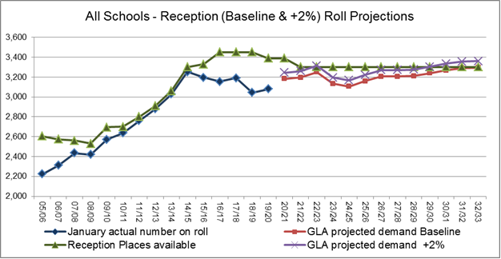
Source: SRP_borough_Spring2020_3_1_BPO2018_lowDomMig_2904201447

School Expansion Programme Phase 3
In addition to the three Phase 3 schools that were expanded in September 2015, a further two schools were expanded in September 2016. Additionally the new free school – St Jérôme opened in September 2016 with 60 permanent places.

Free Schools
The Hujjat Primary School is scheduled to open in September 2020 with 60 permanent places, 50:50 faith based & community. This brings the total of permanent places in September 2020 to 3,510.

A further primary free school – Harrow View Primary (+90) is also planned to open in Harrow. If this school is delivered, it would provide an additional 3 permanent forms of entry:

The opening of the Harrow View Primary School will be timed to align with the development on Kodak West site and occupation of housing. This is estimated to be September 2023. There is an on-going dialogue with the Harrow Schools Trust about the development and opening.

A site for a primary free school has been identified within the development of Poet’s Corner as part of Harrow’s Regeneration Programme. The site forms part of the Phase 2 development and the estimated date of completion of this Phase is 2025/26. This school is planned as a two form entry or 60 places per year group.

Once there is confirmation that the free schools will open the places will be included and once the schools have opened they will be included in the projections.
3.5 Primary Schools Projections by Planning Area

North East Planning Area (GLA Planning Area 1):

Projections for the North East Planning Area are based on data from the following schools and population data for part or all of these wards. The published admission number (PAN) for each school in September 2020 is shown below. The number of temporary (bulge) Reception classes and permanent expansion classes from 2009/10 to 2016/17 are also shown below.

Note: Weald Rise was approved for permanent expansion from 2016-17 and these additional places are included in Table 5 and Table 6 below.

Schools: | PAN | Bulge  classes | Permanent  Expansion |  | Main Wards: |  | Other Wards:
Aylward | 90 | 1 | 1 |  | Belmont |  | Harrow Weald
Stanburn | 120 | 2 | 1 |  | Stanmore Park |  | Edgware
Weald Rise* | 60 | 2 | 1 |  | Canons |  | Queensbury
Whitchurch | 120 | 1 | 1 |  |  |  | Wealdstone
 |  |  |  |  |  |  | Kenton East
 |  |  |  |  |  |  | Kenton West

*Weald Rise formal PAN reduction from 4FE to 2FE from 2020/21

Table 5: Primary projections for the North East Planning Area
Primary projection area: North East
Years R to 6 only
Year | January actual number on roll | Projected demand GLA (Baseline) | Projected demand GLA (R+2% - Yr6) | Places available | Surplus /Deficit of places (Baseline) | Surplus /Deficit of places (R+2% - Yr6)
08/09 | 2,210
09/10 | 2,207
10/11 | 2,254
11/12 | 2,344
12/13 | 2,415
13/14 | 2,494
14/15 | 2,570
15/16 | 2,583
16/17 | 2,592
17/18 | 2,537
18/19 | 2,482
19/20 | 2,439
20/21 |  | 2,437 | 2,444 | 3,030 | 593 | 586
21/22 |  | 2,467 | 2,474 | 3,000 | 533 | 526
22/23 |  | 2,476 | 2,483 | 2,970 | 494 | 487
23/24 |  | 2,492 | 2,499 | 2,910 | 418 | 411
24/25 |  | 2,463 | 2,469 | 2,850 | 387 | 381
25/26 |  | 2,447 | 2,453 | 2,790 | 343 | 337
26/27 |  | 2,451 | 2,457 | 2,730 | 279 | 273
27/28 |  | 2,426 | 2,432 | 2,730 | 304 | 298
28/29 |  | 2,390 | 2,396 | 2,730 | 340 | 334
29/30 |  | 2,359 | 2,365 | 2,730 | 371 | 365
30/31 |  | 2,342 | 2,348 | 2,730 | 388 | 382
31/32 |  | 2,334 | 2,340 | 2,730 | 396 | 390
32/33 |  | 2,329 | 2,335 | 2,730 | 401 | 395
Source: SRP_borough_Spring2020_3_1_BPO2018_lowDomMig_2904201447

Table 5 above shows the Reception (Baseline & +2%) to Year 6 GLA roll projections for the North East Planning Area. The actual number of pupils has been increasing since 2009/10 from 2,207 pupils to 2,592 in 2016/17, however dropped in 2017/18 to 2,537, in 2018/19 to 2,482 and in 2019/20 to 2,439 pupils. The projections for this area start at 2,437 (Baseline) and 2,444 (+2%) for 2020/21 and very slowly rise to 2,492 (Baseline) and 2,499 (+2%) in 2023/24 and then continue steadily decreasing until the end of the period covered in 2032/32. There is no longer a deficit of places in this planning area, a surplus is projected for the period up to 2032/33.

Table 6: Reception projections for the North East Planning Area
Primary Planning Area 1 - North East
Year Reception
School Year | January actual number on roll | Projected demand GLA (Baseline) | Projected demand GLA (+2%) | Reception Places available | Calculated FE - baseline | Calculated FE +2% | Additional FE required  Baseline & +2%
08/09 | 316 |  |  | 330
09/10 | 325 |  |  | 330
10/11 | 346 |  |  | 360
11/12 | 373 |  |  | 390
12/13 | 359 |  |  | 360
13/14 | 374 |  |  | 390
14/15 | 407 |  |  | 420
15/16 | 373 |  |  | 420
16/17 | 346 |  |  | 450
17/18 | 361 |  |  | 450
18/19 | 332 |  |  | 450
19/20 | 307 |  |  | 450
20/21 |  | 326 | 333 | 390 | 2.13 | 1.92 | 0
21/22 |  | 336 | 343 | 390 | 1.80 | 1.58 | 0
22/23 |  | 339 | 346 | 390 | 1.70 | 1.47 | 0
23/24 |  | 326 | 333 | 390 | 2.13 | 1.92 | 0
24/25 |  | 317 | 323 | 390 | 2.43 | 2.22 | 0
25/26 |  | 316 | 322 | 390 | 2.47 | 2.26 | 0
26/27 |  | 315 | 321 | 390 | 2.50 | 2.29 | 0
27/28 |  | 310 | 316 | 390 | 2.67 | 2.46 | 0
28/29 |  | 309 | 315 | 390 | 2.70 | 2.49 | 0
29/30 |  | 309 | 315 | 390 | 2.70 | 2.49 | 0
30/31 |  | 310 | 316 | 390 | 2.67 | 2.46 | 0
31/32 |  | 310 | 316 | 390 | 2.67 | 2.46 | 0
32/33 |  | 310 | 316 | 390 | 2.67 | 2.46 | 0
Source: SRP_borough_Spring2020_3_1_BPO2018_lowDomMig_2904201447; *Weald Rise has had a formal reduction in it’s PAN by 2FE from 2020/21.

Table 6 and Chart 3 show the GLA roll projections for the Reception year group for the North East Planning Area. The actual number on roll decreased by 1 form of entry from 2014/15 to 2015/16 and then further decreased by another form of entry from 2015/16 to 2016/17. The number on roll increased by 15 pupils in 2017/18, but then dropped by a form of entry to 332 in 2018/19 and by 25 places to 307 in 2019/20. Future numbers for the area are overall projected to drop slightly over the period covered, from 326 (Baseline) and 333 (+2%) in 2020/21 to 310 (Baseline) and 316 (+2%) by 2032/33. There is projected to be a surplus of up to 3 forms of entry in this area.

The outcome of the latest round of rising five offers (June 2020) for a Reception place in the North East primary planning area schools in September 2020 is resulting in 15% availability of the PAN for this area.

Chart 3: Reception projections for the North East Planning Area
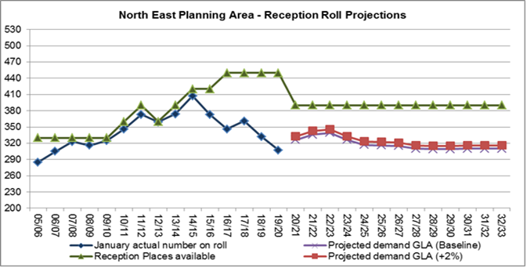
Source: SRP_borough_Spring2020_3_1_BPO2018_lowDomMig_2904201447

North West Planning Area (GLA Planning Area 2):

Projections for the North West Planning Area are based on data from the following schools and population data for part or all of these wards. The published admission number (PAN) for each school in September 2020 is shown below.

The number of temporary (bulge) Reception classes and permanent expansion classes from 2009/10 to 2016/17 are also shown below.

Schools: | PAN | Bulge  classes | Perm  Exp |  | Main Wards: |  | Other Wards:
Cannon Lane | 120 | 2 | 1 |  | Pinner |  | Headstone South
Cedars Manor | 60* | 2 | 1 |  | Pinner South |  | Rayners Lane
Grimsdyke | 90 | 1** | 1 |  | Hatch End |  | Roxbourne
Longfield | 120*** | 2 | 1 |  | Headstone North |  | Harrow on the Hill
Pinner Wood | 90 | 2 | 1 |  | Harrow Weald |  | West Harrow
West Lodge | 90 | 0 | 0
Perm Exp – Permanent Expansions; *Cedars Manor formal PAN reduction from 3FE to 2FE from 2020/21; **Grimsdyke also opened a Year 2 bulge class in September 2014; ***A formal reduction of 1FE has been agreed for Longfield Primary from 2021/22.

Table 7: Primary projections for the North West Planning Area
Primary projection area: North West
Years R to 6 only
Year | January actual number on roll | Projected demand GLA (Baseline) | Projected demand GLA (R+2% - Yr6) | Places available | Surplus /Deficit of places (Baseline) | Surplus /Deficit of places (R+2% - Yr6)
08/09 | 3,064
09/10 | 3,084
10/11 | 3,162
11/12 | 3,195
12/13 | 3,284
13/14 | 3,425
14/15 | 3,564
15/16 | 3,711
16/17 | 3,765
17/18 | 3,782
18/19 | 3,898
19/20 | 3,931
20/21 |  | 3,950 | 3,961 | 4,110 | 160 | 149
21/22 |  | 3,917 | 3,928 | 4,080 | 163 | 152
22/23 |  | 3,877 | 3,888 | 4,020 | 143 | 132
23/24 |  | 3,836 | 3,847 | 3,960 | 124 | 114
24/25 |  | 3,784 | 3,794 | 3,900 | 116 | 106
25/26 |  | 3,780 | 3,790 | 3,840 | 60 | 50
26/27 |  | 3,752 | 3,762 | 3,810 | 58 | 48
27/28 |  | 3,725 | 3,735 | 3,780 | 55 | 45
28/29 |  | 3,707 | 3,717 | 3,780 | 73 | 63
29/30 |  | 3,690 | 3,700 | 3,780 | 90 | 80
30/31 |  | 3,679 | 3,689 | 3,780 | 101 | 91
31/32 |  | 3,679 | 3,689 | 3,780 | 101 | 91
32/33 |  | 3,684 | 3,694 | 3,780 | 96 | 86
Source: SRP_borough_Spring2020_3_1_BPO2018_lowDomMig_2904201447

The GLA roll projections in Table 7 above shows that the Reception (Baseline & +2%) to Year 6 number on roll for this planning area has increased from 3,711 in 2015/16 to 3,950 (Baseline) & 3,961 (+2%) in 2020/21 t 3,684 (Baseline) & 3,694 (+2%) in 2032/33. There is a surplus of places projected for this area for the duration of the period covered.

Table 8: Reception projections for the North West Planning Area
Primary Planning Area 2 - North West
Year Reception
School Year | January actual number on roll | Projected demand GLA (Baseline) | Projected demand GLA (+2%) | Reception Places available | Calculated FE - baseline | Calculated FE +2% | Total Additional FE required  baseline & +2% | Total Reception Places to meet - baseline & +2%
08/09 | 430 |  |  | 450
09/10 | 451 |  |  | 480
10/11 | 498 |  |  | 510
11/12 | 475 |  |  | 480
12/13 | 500 |  |  | 510
13/14 | 537 |  |  | 540
14/15 | 562 |  |  | 570
15/16 | 590 |  |  | 600
16/17 | 547 |  |  | 600
17/18 | 544 |  |  | 600
18/19 | 540 |  |  | 600
19/20 | 561 |  |  | 570
20/21 |  | 549 | 560 | 570 | 0.70 | 0.33 | 0 | 570
21/22 |  | 532 | 543 | 540** | 0.27 | -0.09 | 0 | 540
22/23 |  | 559 | 570 | 540 | -0.63 | -1.01 | 1 | 570
23/24 |  | 525 | 536 | 540 | 0.50 | 0.15 | 0 | 540
24/25 |  | 512 | 522 | 540 | 0.93 | 0.59 | 0 | 540
25/26 |  | 511 | 521 | 540 | 0.97 | 0.63 | 0 | 540
26/27 |  | 509 | 519 | 540 | 1.03 | 0.69 | 0 | 540
27/28 |  | 506 | 516 | 540 | 1.13 | 0.80 | 0 | 540
28/29 |  | 507 | 517 | 540 | 1.10 | 0.76 | 0 | 540
29/30 |  | 513 | 523 | 540 | 0.90 | 0.56 | 0 | 540
30/31 |  | 516 | 526 | 540 | 0.80 | 0.46 | 0 | 540
31/32 |  | 517 | 527 | 540 | 0.77 | 0.42 | 0 | 540
32/33 |  | 518 | 528 | 540 | 0.73 | 0.39 | 0 | 540
Source: SRP_borough_Spring2020_3_1_BPO2018_lowDomMig_2904201447; *Cedars Manor formal PAN reduction by 1FE from 2020/21; ** the 21/22 places include the reduction of 1FE at Longfield Primary.

Table 8 above and Chart 4 below show the GLA roll projections for the Reception year group for the North West Planning Area. The actual roll increased by 1 form of entry from 562 in 2014/15 to 590 in 2015/16, however it dropped to 547 in 2016/17 and continued to drop very slightly to 540 in 2018/19, but then increased by another 21 places to 561 in 2019/20. The projections for this area fluctuate over the period covered, from 549 – Baseline & 560 +2% in 2020/21 to 518 – Baseline & 528 +2% in 2032/33. There is a projected deficit of a small number of places based on the +2% SRP in 2021/22 and 2022/23, for the remainder of the period there is a projected surplus of 1 form of entry for this area.

The outcome of the latest round of rising five offers (June 2020) for a Reception place in the North West primary planning area schools in September 2020 is resulting in 3% availability of the PAN for this area.

Chart 4: Current number on roll compared to roll projections and places available for the North West Planning Area
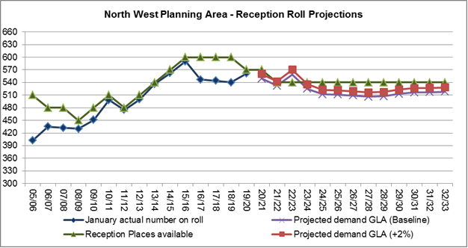
Source: SRP_borough_Spring2020_3_1_BPO2018_lowDomMig_2904201447
South East Planning Area (GLA Planning Area 3):

Projections for the South East Planning Area are based on data from the following schools and population data for part or all of these wards. The published admission number (PAN) for each school in September 2020 is shown below. The number of temporary (bulge) Reception classes and permanent expansion classes from 2009/10 to 2016/17 are also shown below.

Schools: | PAN | Bulge classes | Perm Exp |  | Main Wards: |  | Other Wards:
Camrose | 60 | 1* | 1 |  | Edgware |  | Belmont
Glebe | 90 | 2* | 1 |  | Queensbury |  | Canons
Kenmore Park | 120** | 2 | 1 |  | Kenton East
Priestmead | 120 | 1 | 1 |  | Kenton West
Stag Lane | 120 | 1 | 1
Perm Exp – Permanent Expansions; *Camrose Primary also opened a Year 1 bulge class in October 2011 and Glebe opened a Year 4 bulge class in September 2014. **A formal reduction of 1FE has been agreed for Kenmore Park from 2021/22.

Stag Lane was approved for permanent expansion from 2016/17 and these additional places are included in Table 9 and Table 10 below.

Table 9: Primary projections for the South East Planning Area
Primary projection area: South East
Years R to 6 only
Year | January actual number on roll | Projected demand GLA (Baseline) | Projected demand GLA (R+2% - Yr6) | Places available | Surplus /Deficit of places (Baseline) | Surplus /Deficit of places (R+2% - Yr6)
08/09 | 2,307
09/10 | 2,371
10/11 | 2,480
11/12 | 2,589
12/13 | 2,669
13/14 | 2,808
14/15 | 2,964
15/16 | 3,050
16/17 | 3,176
17/18 | 3,173
18/19 | 3,209
19/20 | 3,218
20/21 |  | 3,323 | 3,333 | 3,540 | 217 | 207
21/22 |  | 3,377 | 3,387 | 3,510 | 133 | 123
22/23 |  | 3,393 | 3,403 | 3,510 | 117 | 107
23/24 |  | 3,413 | 3,423 | 3,480 | 67 | 57
24/25 |  | 3,407 | 3,417 | 3,450 | 43 | 33
25/26 |  | 3,408 | 3,418 | 3,420 | 12 | 2
26/27 |  | 3,414 | 3,424 | 3,390 | -24 | -34
27/28 |  | 3,386 | 3,396 | 3,360 | -26 | -36
28/29 |  | 3,357 | 3,367 | 3,360 | 3 | -7
29/30 |  | 3,336 | 3,346 | 3,360 | 24 | 14
30/31 |  | 3,327 | 3,337 | 3,360 | 33 | 23
31/32 |  | 3,329 | 3,339 | 3,360 | 31 | 21
32/33 |  | 3,337 | 3,347 | 3,360 | 23 | 13
Source: SRP_borough_Spring2020_3_1_BPO2018_lowDomMig_2904201447
Table 9 above shows the actual number on roll and projection figures for the South East Planning Area for Reception to Year 6. The actual number of pupils has continued increasing from 2,307 in 2008/09 to 3,218 in 2019/20. The projections for this area are 3,323 (Baseline) and 3,333 (+2%) in 2020/21 and peak at 3,414 (Baseline) and 3,424 (+2%) in 2026/27, after which point the projections drop slightly, and steady at circa 3.3k by 2032/33. The surplus of places in this area are projected to fall from 217 (Baseline) and 207 (+2%) places in 2020/21 to -20+ (Baseline) and -30+ (+2%) places in 2026/27 and 2027/28.

Table 10: Reception projections for the South East Planning Area
Primary Planning Area 3 - South East
Year Reception
School Year | January actual number on roll | Projected demand GLA (Baseline) | Projected demand GLA (+2%) | Reception Places available | Calculated FE - baseline | Calculated FE +2% | Total additional FE required  baseline & +2% | Total Reception Places to meet - baseline & +2%
08/09 | 332 |  |  | 352
09/10 | 348 |  |  | 360
10/11 | 380 |  |  | 390
11/12 | 419 |  |  | 420
12/13 | 417 |  |  | 420
13/14 | 421 |  |  | 420
14/15 | 507 |  |  | 510
15/16 | 467 |  |  | 480
16/17 | 485 |  |  | 510
17/18 | 494 |  |  | 510
18/19 | 469 |  |  | 510
19/20 | 471 |  |  | 510
20/21 |  | 517 | 527 | 510 | -0.23 | -0.58 | 1 | 540
21/22 |  | 521 | 531 | 480** | -1.37 | -1.71 | 2 | 540
22/23 |  | 512 | 522 | 480 | -1.07 | -1.41 | 1 | 510
23/24 |  | 499 | 509 | 480 | -0.63 | -0.97 | 1 | 510
24/25 |  | 482 | 492 | 480 | -0.07 | -0.39 | 0 | 480
25/26 |  | 480 | 490 | 480 | 0.00 | -0.32 | 0 | 480
26/27 |  | 479 | 489 | 480 | 0.03 | -0.29 | 0 | 480
27/28 |  | 475 | 485 | 480 | 0.17 | -0.15 | 0 | 480
28/29 |  | 477 | 487 | 480 | 0.10 | -0.22 | 0 | 480
29/30 |  | 479 | 489 | 480 | 0.03 | -0.29 | 0 | 480
30/31 |  | 484 | 494 | 480 | -0.13 | -0.46 | 0 | 480
31/32 |  | 486 | 496 | 480 | -0.20 | -0.52 | 1 | 510
32/33 |  | 488 | 498 | 480 | -0.27 | -0.59 | 1 | 510
Source: SRP_borough_Spring2020_3_1_BPO2018_lowDomMig_2904201447; ** the 21/22 places include the reduction of 1FE at Kenmore Park Infant.

Table 10 above and Chart 5 below show that the Reception numbers on roll have continued to rise in the South East planning area, increasing from 296 in 2006/07 to 507 in 2014/15. The number on roll fell to 467 in 2015/16, but then rose again in 2017/18 to 494, however it dropped by 26 places to 469 in 2018/19 and then remained steady at 471 in 2019/20. The projections in this area start at 517 (Baseline) and 527 (+2%) in 2020/21 but steadily fall over the period dropping to 475 (Baseline) and 485 (+2%) in 2027/28. The number of places available in this area are very close to the projections for the period covered, with a projected deficit of 1 to 2 FE from 2020/21, however the neighbouring planning areas have sufficient places.

The outcome of the latest round of rising five offers (June 2020) for a Reception place in the South East primary planning area schools in September 2020 is resulting in 8% availability of the PAN for this area.

Chart 5: Reception projections for the South East Planning Area
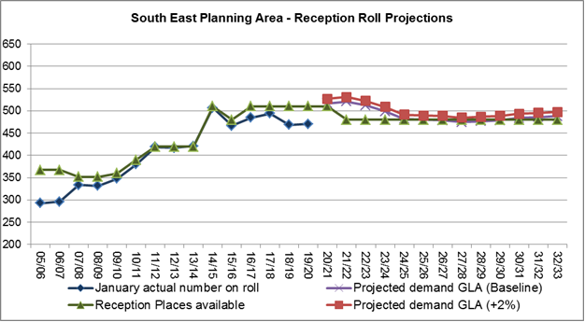
Source: SRP_borough_Spring2020_3_1_BPO2018_lowDomMig_2904201447
South West Planning Area (GLA Planning Area 4):

Projections for the South West Planning Area are based on data from the following schools and population data for part or all of these wards. The published admission number (PAN) for each school in September 2020 is shown below. The number of temporary (bulge) Reception classes and permanent expansion classes from 2009/10 to 2016/17 are also shown below.

Schools: | PAN | Bulge classes | Perm Exp |  | Main Wards: |  | Other Wards:
Earlsmead | 60 | 0 | 0 |  | Rayners Lane |  | Headstone South
Grange | 90 | 2* | 1 |  | Roxbourne |  | Greenhill
Heathland | 90 | 0 | 0 |  | Roxeth
Newton Farm | 60 | 1 | 1 |  | West Harrow
Roxbourne | 90*** | 0 | 0 |  | Harrow on the Hill
Roxeth | 60 | 1 | 0
Vaughan | 90 | 1 | 1
Welldon Park | 60** | 1 | 1
Perm Exp – Permanent Expansions; *Grange also opened a Year 4 bulge class in September 2014; **Welldon Park School’s PAN has been reduced from 3FE to 2FE from 2020/21. ***A formal reduction of 1FE has been agreed for Roxbourne Primary from 2021/22.

Table 11: Primary projections for the South West Planning Area
Primary projection area: South West
Years R to 6 only
Year | January actual number on roll | Projected demand GLA (Baseline) | Projected demand GLA (R+2% - Yr6) | Places available | Surplus /Deficit of places (Baseline) | Surplus /Deficit of places (R+2% - Yr6)
08/09 | 3,219
09/10 | 3,302
10/11 | 3,342
11/12 | 3,485
12/13 | 3,622
13/14 | 3,786
14/15 | 3,899
15/16 | 3,959
16/17 | 3,879
17/18 | 3,858
18/19 | 3,901
19/20 | 3,878
20/21 |  | 3,750 | 3,761 | 4,320 | 570 | 559
21/22 |  | 3,671 | 3,682 | 4,290 | 619 | 608
22/23 |  | 3,602 | 3,613 | 4,230 | 628 | 617
23/24 |  | 3,535 | 3,545 | 4,170 | 635 | 625
24/25 |  | 3,475 | 3,485 | 4,110 | 635 | 625
25/26 |  | 3,478 | 3,488 | 4,050 | 572 | 562
26/27 |  | 3,450 | 3,460 | 4,020 | 570 | 560
27/28 |  | 3,412 | 3,422 | 3,990 | 578 | 568
28/29 |  | 3,378 | 3,388 | 3,990 | 612 | 602
29/30 |  | 3,353 | 3,363 | 3,990 | 637 | 627
30/31 |  | 3,344 | 3,354 | 3,990 | 646 | 636
31/32 |  | 3,342 | 3,352 | 3,990 | 648 | 638
32/33 |  | 3,341 | 3,351 | 3,990 | 649 | 639
Source: SRP_borough_Spring2020_3_1_BPO2018_lowDomMig_2904201447
Table 11 above shows the number of Reception (Baseline & +2%) to Year 6 pupils in the South West Planning Area. Pupil numbers have been increasing in this area and were at their highest with 3,959 pupils on roll in 2015/16, however the number of actual pupils fell by 3 forms of entry to 3,879 in 2016/17. The number on roll increased by 43 places to 3,901 in 2018/19 but dropped by 23 places to 3,878 in 2019/20. The projections for this area start at 3,750 (Baseline) and 3,761 (+2%) in 2020/21 but after this point drop continue to fall to 3,341 (Baseline) and 3,351 (+2%) by 2032/33. There is a significant surplus of places in this area from 570 (Baseline) and 559 (+2%) in 2020/21 to 649 (Baseline) and 639 (+2%) by 2032/33.

Table 12: Reception projections for the South West Planning Area
Primary Planning Area 4 - South West
Year Reception
School Year | January actual number on roll | Projected demand GLA (Baseline) | Projected demand GLA (+2%) | Reception Places available | Calculated FE - baseline | Calculated FE +2% | Additioanl FE required to meet  baseline | Total Reception Places to meet - baseline & +2%
08/09 | 469 |  |  | 506
09/10 | 505 |  |  | 566
10/11 | 496 |  |  | 510
11/12 | 531 |  |  | 540
12/13 | 562 |  |  | 570
13/14 | 591 |  |  | 600
14/15 | 587 |  |  | 600
15/16 | 578 |  |  | 630
16/17 | 540 |  |  | 630
17/18 | 545 |  |  | 630
18/19 | 519 |  |  | 630
19/20 | 530 |  |  | 600
20/21 |  | 546 | 557 | 600 | 1.80 | 1.44 | 0 | 600
21/22 |  | 533 | 544 | 570** | 1.23 | 0.88 | 0 | 570
22/23 |  | 536 | 547 | 570 | 1.13 | 0.78 | 0 | 570
23/24 |  | 509 | 519 | 570 | 2.03 | 1.69 | 0 | 570
24/25 |  | 496 | 506 | 570 | 2.47 | 2.14 | 0 | 570
25/26 |  | 495 | 505 | 570 | 2.50 | 2.17 | 0 | 570
26/27 |  | 491 | 501 | 570 | 2.63 | 2.31 | 0 | 570
27/28 |  | 487 | 497 | 570 | 2.77 | 2.44 | 0 | 570
28/29 |  | 485 | 495 | 570 | 2.83 | 2.51 | 0 | 570
29/30 |  | 490 | 500 | 570 | 2.67 | 2.34 | 0 | 570
30/31 |  | 493 | 503 | 570 | 2.57 | 2.24 | 0 | 570
31/32 |  | 494 | 504 | 570 | 2.53 | 2.20 | 0 | 570
32/33 |  | 494 | 504 | 570 | 2.53 | 2.20 | 0 | 570
Source: SRP_borough_Spring2020_3_1_BPO2018_lowDomMig_2904201447; ** the 21/22 places include the reduction of 1FE at Roxbourne Primary.

Table 12 above and Chart 6 below show the Reception numbers and projections in the South West planning area. Actual pupil numbers for this area have fluctuated over the period included in the table above, increasing by 1 form of entry each year from 2011/13 to 2013/14. However the numbers have been falling since 2013/14, dropping to 540 in 2016/17, they increased very slightly to 545 in 2017/18, dropped again in 2018/19 to 519 but increased to 530 in 2019/20. The projections for this area are projected to fall over the period covered, ranging from 546 (Baseline) and 557 (+2%) in 2020/21 to 494 (Baseline) and 504 (+2%) in 2032/33. There is a surplus of 1 to 3 forms of entry over the period covered in the table. Note: The spike in Reception places in 2009/10 arose from bulge Reception places opened that year.

The outcome of the latest round of rising five offers (June 2020) for a Reception place in the South West primary planning area schools in September 2020 is resulting in 10% availability of the PAN for this area.

Chart 6: Current Reception NOR compared to roll projections and places available for the South West Planning Area
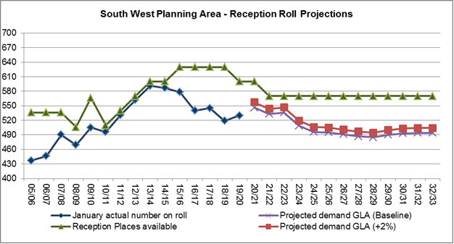
Source: SRP_borough_Spring2020_3_1_BPO2018_lowDomMig_2904201447
Central Planning Area (GLA Planning Area 5):

Projections for the Central Planning Area are based on data from the following schools and population data for part or all of these wards. The published admission number (PAN) for each school in September 2020 is shown below.

The number of temporary (bulge) Reception classes and permanent expansion classes from 2009/10 to 2016/17 are also shown below.

Schools: | PAN | Bulge classes | Perm Exp* |  | Main Wards: |  | Other Wards:
Belmont | 90 | 1 | 1 |  | Wealdstone |  | Harrow Weald
Elmgrove | 120 | 2 | 1 |  | Marlborough |  | Hatch End
Marlborough | 90 | 1** | 1 |  | Headstone South |  | Belmont
Norbury | 90 | 3 | 1 |  | Greenhill |  | Kenton West
Pinner Park | 120 | 2 | 1 |  |  |  | West Harrow
Whitefriars | 90 | 1 | 1
* Perm Exp – Permanent Expansions;
** Marlborough also opened a Year 3 bulge class in September 2014 and in September 2015 opened a Year 1 and vertical Year 4 & Year 5 (15 places each) bulge classes.

The Central Planning area is an area of significant housing development as part of Harrow’s Opportunity Area and the demand for places will be monitored closely. The Government free school (Saint Jérôme Bilingual School) opened in September 2016, providing 2 forms of entry, of which 12 places are allocated on foundation/faith basis, the remainder are offered to the 2 founder’s children, siblings and open places within the catchment area. The 48 open places are included in Tables 13 and 14 below.

There is one further school in the Government’s Free School programme that would contribute to the provision of up to an additional 3 forms of entry in this Central Planning Area, Harrow View School, which is announced to open in September 2023. In the context of the potential child yield impact across year groups of the housing development programme, which will not be factored fully into the projections until the types of housing units is known and approved, the projected deficit of places (R+2% to Y6) is a school place planning issue that will be monitored closely.

Additionally the need for a school has been identified as a part of the Civic Centre regeneration site ‘Poet’s Corner’ within the Central Planning Area. This school has not been factored into the projections either.

Table 13: Primary projections for the Central Planning Area
Primary projection area: Central
Years R to 6 only
Year | January actual number on roll | Projected demand GLA (Baseline) | Projected demand GLA (R+2% - Yr6) | Places available | Surplus /Deficit of places (Baseline) | Surplus /Deficit of places (R+2% - Yr6)
08/09 | 2,693
09/10 | 2,750
10/11 | 2,833
11/12 | 2,944
12/13 | 3,098
13/14 | 3,294
14/15 | 3,473
15/16 | 3,678
16/17 | 3,869
17/18 | 4,040
18/19 | 4,080
19/20 | 4,220
20/21 |  | 4,220 | 4,233 | 4,470 | 250 | 237
21/22 |  | 4,236 | 4,250 | 4,488 | 252 | 238
22/23 |  | 4,309 | 4,323 | 4,536 | 227 | 213
23/24 |  | 4,358 | 4,372 | 4,536 | 178 | 164
24/25 |  | 4,532 | 4,546 | 4,536 | 4 | -10
25/26 |  | 4,781 | 4,796 | 4,536 | -245 | -260
26/27 |  | 5,008 | 5,024 | 4,536 | -472 | -488
27/28 |  | 5,105 | 5,122 | 4,536 | -569 | -586
28/29 |  | 5,157 | 5,174 | 4,536 | -621 | -638
29/30 |  | 5,208 | 5,225 | 4,536 | -672 | -689
30/31 |  | 5,266 | 5,283 | 4,536 | -730 | -747
31/32 |  | 5,325 | 5,342 | 4,536 | -789 | -806
32/33 |  | 5,366 | 5,383 | 4,536 | -830 | -847
Source: SRP_borough_Spring2020_3_1_BPO2018_lowDomMig_2904201447

Table 13 above shows the projected Reception (Baseline & +2%) to Year 6 pupil numbers in this Planning Area up to 2032/33. The actual numbers on roll have been increasing substantially in this area, from 3,098 in 2012/13 to 4,080 in 2018/19 and then increased by another 140 places to 4220 in 2019/20.

The projections for this area are projected to continue increasing, rising from 4,220 (Baseline) and 4,233 (+2%) in 2020/21 to 5,366 (Baseline) and 5,383 (+2%) by 2032/33. There are sufficient places in this area until 2025/26, at which point there is a projected deficit of 245 (Baseline) and 260 (+2%) places. The deficit in places is set to increase substantially over the period covered in the table, with the projections suggesting a shortfall of up to 830 Baseline and 847 places by 2032/33. Please note that this table includes St Jérôme Bilingual School’s 48 non-faith based places.

Table 14: Reception projections for the Central Planning Area
Primary Planning Area 5 - Central
Year Reception
School Year | January actual number on roll | Projected demand GLA (Baseline) | Projected demand GLA (+2%) | Reception Places available | Calculated FE - baseline | Calculated FE +2% | Additional FE required  Baseline/+2% | Total Reception Places to meet baseline | Total Reception Places to meet +2%
08/09 | 403 |  |  | 412
09/10 | 436 |  |  | 450
10/11 | 440 |  |  | 450
11/12 | 474 |  |  | 480
12/13 | 507 |  |  | 510
13/14 | 542 |  |  | 540
14/15 | 591 |  |  | 600
15/16 | 593 |  |  | 600
16/17 | 639 |  |  | 648
17/18 | 645 |  |  | 648
18/19 | 600 |  |  | 648
19/20 | 640 |  |  | 648
20/21 |  | 657 | 670 | 648 | -0.30 | -0.74 | 0/1 | 648 | 678
21/22 |  | 677 | 691 | 648 | -0.97 | -1.42 | 1 | 678 | 678
22/23 |  | 699 | 713 | 648 | -1.70 | -2.17 | 2 | 678 | 708
23/24 |  | 690 | 704 | 648 | -1.40 | -1.86 | 1/2 | 708 | 708
24/25 |  | 719 | 733 | 648 | -2.37 | -2.85 | 2/3 | 708 | 738
25/26 |  | 767 | 782 | 648 | -3.97 | -4.48 | 4 | 738 | 768
26/27 |  | 812 | 828 | 648 | -5.47 | -6.01 | 5/6 | 768 | 768
27/28 |  | 827 | 844 | 648 | -5.97 | -6.52 | 6/7 | 768 | 798
28/29 |  | 829 | 846 | 648 | -6.03 | -6.59 | 6/7 | 768 | 798
29/30 |  | 838 | 855 | 648 | -6.33 | -6.89 | 6/7 | 768 | 798
30/31 |  | 847 | 864 | 648 | -6.63 | -7.20 | 7 | 798 | 798
31/32 |  | 860 | 877 | 648 | -7.07 | -7.64 | 7/8 | 798 | 798
32/33 |  | 860 | 877 | 648 | -7.07 | -7.64 | 7/8 | 798 | 798
Source: SRP_borough_Spring2020_3_1_BPO2018_lowDomMig_2904201447

As can be seen by the deficit of places projected in the table above the Central Planning area is an area of significant housing development, which is a part of Harrow’s Opportunity Area. The demand for places in this planning area are being closely monitored, with 5FE planned to meet the demand via the schools proposed within the Harrow View and Poet’s Corner developments. More details about the progress of the developments in this planning area can be found in Annexe 2: Overview of Harrow’s population and changes 2020.

Table 14 above and Chart 7 below show that the number of Reception pupils in the Central planning area has significantly increased over the last few years, increasing by just over 1 form of entry per year from 2010/11 to 2013/14 and nearly 2 forms of entry from 2013/14 to 2014/15. The 2016/17 Reception number had a step increase to 639 pupils, from 593 in 2015/16, and the 2017/18 number on roll rose slightly to 645. This increase is due to the inclusion of the non-faith school places available at the St Jérôme Bilingual School, which opened in September 2016. However the numbers dropped by 44 places to 600 in 2018/19 but increased to 640 in 2019/20.

The projections for this planning area are projected to increase, from 657 (Baseline) and 670 (+2%) in 2020/21 to 860 (Baseline) and 877 (+2%) by 2032/33. There is a projected deficit of just under 1 forms of entry in 2020/21, increasing to 2 FE (Baseline) and 3 FE (+2%) by 2024/25. The deficit is projected to continue up to the end of the period covered in the table. However it should be noted that the neighbouring planning areas have sufficient places.

The outcome of the latest round of rising five offers (June 2020) for a Reception place in the Central primary planning area schools in September 2020 is resulting in 1% availability of the PAN for this area.

Chart 7: Current NOR compared to roll projections and places available for the Central Planning Area
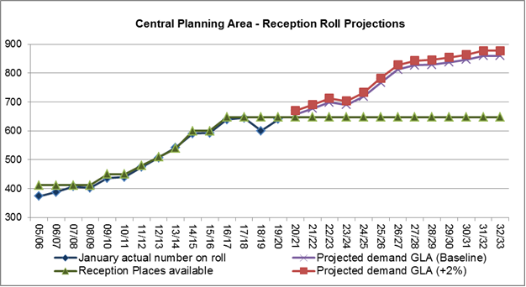
Source: SRP_borough_Spring2020_3_1_BPO2018_lowDomMig_2904201447
Faith schools: (GLA Planning Area 6)

For the purposes of place planning, the faith schools are considered as a single planning area. Since historically voluntary aided schools in Harrow are full, GLA projections of pupil numbers at faith schools amount to a ‘top slice’ of the projected school roll. These projections do not reflect demand for faith based school places.

The voluntary aided schools and academy schools, with their planned admission number (PAN) as at September 2020 are listed in Table 15 below, along with the number of temporary (bulge) Reception classes and permanent expansion classes from 2009/10 to 2016/17.

Table 15: Faith schools
Schools: | PAN | Bulge classes | Permanent Expansions
St Anselm’s Catholic Primary School | 60 | 0 | 0
St Bernadette’s Catholic Primary School | 60 | 0 | 0
St George’s Catholic Primary School | 60 | 1 | 0
St John Fisher Catholic Primary School | 90 | 1 | 1
St Joseph’s Catholic Primary School | 60 | 0 | 0
St Teresa’s Catholic Primary School | 60 | 0 | 0
St John’s Church of England School | 60 | 0 | 0
Krishna Avanti Primary School | 60 | 0 | 1
Avanti-House Primary School | 60 | 0 | 0
Moriah Jewish Day School | 30 | 0 | 0
St Jérôme Church of England Bilingual School | 12* | 0 | 0
Hujjat Primary School** | 60 | 0 | 0
*12 of the 60 PAN at St Jérôme are allocated to foundation, faith places
** Opening September 2020

Table 16 below shows that the actual number on roll in this planning area has increased. There has been an increase of 3 forms of entry from 2014/15 (3,705) to 2015/16 (3,796), then a further increase of just over 2 forms of entry from 2015/16 to 3,864 in 2016/17, over 3 forms of entry increase in 2017/18, just under 4 forms of entry increase (4,074 on roll) in 2018/19 but a decrease to 4,028 2019/20.

The GLA projections show a continued demand for places in the faith schools, with projections increasing from 4,011 (Baseline) and 4,023 (+2%) in 2020/21 that continues to rise over the period covered in the table, to 4,138 (Baseline) and 4,151 (+2%) by 2032/33. There is a projected surplus of places throughout the period covered in the table below.

Table 16: Primary projections for faith schools
Primary projection area: Faith Schools
Years R to 6 only
Year | January actual number on roll | Projected demand GLA (Baseline) | Projected demand GLA (R+2% - Yr6) | Places available | Surplus /Deficit of places (Baseline) | Surplus /Deficit of places (R+2% - Yr6)
08/09 | 3,144
09/10 | 3,206
10/11 | 3,255
11/12 | 3,303
12/13 | 3,394
13/14 | 3,537
14/15 | 3,705
15/16 | 3,796
16/17 | 3,864
17/18 | 3,962
18/19 | 4,074
19/20 | 4,028
20/21 |  | 4,011 | 4,023 | 4,320 | 309 | 297
21/22 |  | 4,008 | 4,020 | 4,392 | 384 | 372
22/23 |  | 3,997 | 4,009 | 4,464 | 467 | 455
23/24 |  | 3,997 | 4,009 | 4,524 | 527 | 515
24/25 |  | 3,984 | 3,996 | 4,584 | 600 | 588
25/26 |  | 4,036 | 4,048 | 4,644 | 608 | 596
26/27 |  | 4,084 | 4,096 | 4,704 | 620 | 608
27/28 |  | 4,089 | 4,101 | 4,704 | 615 | 603
28/29 |  | 4,080 | 4,092 | 4,704 | 624 | 612
29/30 |  | 4,080 | 4,092 | 4,704 | 624 | 612
30/31 |  | 4,095 | 4,107 | 4,704 | 609 | 597
31/32 |  | 4,117 | 4,129 | 4,704 | 587 | 575
32/33 |  | 4,138 | 4,151 | 4,704 | 566 | 554
Source: SRP_borough_Spring2020_3_1_BPO2018_lowDomMig_2904201447

Table 17 and Chart 8 below show that the number of Reception pupils in the faith schools has ranged from 597 in 2014/15 to 600 in 2017/18, but dropped to 583 in 2018/19 and fell again to 570 in 2019/20. The Reception projections for this area are set to increase very steadily from 587 (Baseline) and 599 (+2%) in 2020/21 to 625 (Baseline) and 638 (+2%) by 2032/33. There is a surplus of places projected over the period covered, as can be seen in the table below.

Table 17: Reception projections for Faith schools
Primary Planning Area 6 - Faith Schools
Year Reception
School Year | January actual number on roll | Projected demand GLA (Baseline) | Projected demand GLA (+2%) | Reception Places available | Calculated FE - baseline | Calculated FE +2% | Additional FE required to meet baseline | Total Reception Places to meet baseline & +2%
08/09 | 469 |  |  | 480
09/10 | 506 |  |  | 510
10/11 | 477 |  |  | 480
11/12 | 487 |  |  | 490
12/13 | 534 |  |  | 540
13/14 | 564 |  |  | 570
14/15 | 597 |  |  | 600
15/16 | 594 |  |  | 600
16/17 | 597 |  |  | 612
17/18 | 600 |  |  | 612
18/19 | 583 |  |  | 612
19/20 | 570 |  |  | 612
20/21 |  | 587 | 599 | 672 | 2.83 | 2.44 | 0 | 672
21/22 |  | 597 | 609 | 672 | 2.50 | 2.10 | 0 | 672
22/23 |  | 604 | 616 | 672 | 2.27 | 1.86 | 0 | 672
23/24 |  | 584 | 596 | 672 | 2.93 | 2.54 | 0 | 672
24/25 |  | 579 | 591 | 672 | 3.10 | 2.71 | 0 | 672
25/26 |  | 589 | 601 | 672 | 2.77 | 2.37 | 0 | 672
26/27 |  | 599 | 611 | 672 | 2.43 | 2.03 | 0 | 672
27/28 |  | 600 | 612 | 672 | 2.40 | 2.00 | 0 | 672
28/29 |  | 604 | 616 | 672 | 2.27 | 1.86 | 0 | 672
29/30 |  | 611 | 623 | 672 | 2.03 | 1.63 | 0 | 672
30/31 |  | 618 | 630 | 672 | 1.80 | 1.39 | 0 | 672
31/32 |  | 623 | 635 | 672 | 1.63 | 1.22 | 0 | 672
32/33 |  | 625 | 638 | 672 | 1.57 | 1.15 | 0 | 672
Source: SRP_borough_Spring2020_3_1_BPO2018_lowDomMig_2904201447

Please note that the table above contains the St Jérôme Bilingual school 12 foundation/faith places, and the remaining 48 places of this school are included in the Central planning area.

The outcome of the latest round of rising five offers (June 2020) for a Reception place in the Central primary planning area schools in September 2020 is resulting in 8% availability of the PAN for this area. The Hujjat Primary School’s pupil numbers and places have been incoroproated into this Planning Area.

Chart 8: Current NOR compared to roll projections and places available for Faith Schools

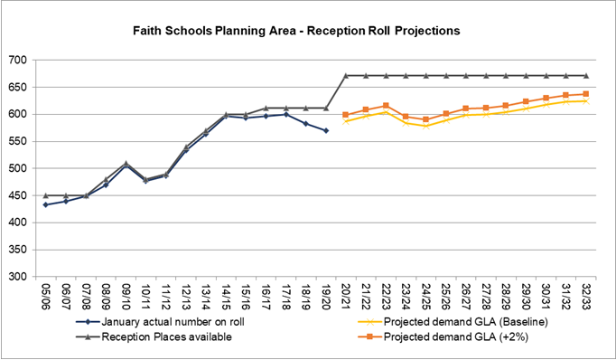
Source: SRP_borough_Spring2020_3_1_BPO2018_lowDomMig_2904201447

3.6 Secondary Schools

Secondary school roll projections are presented on the basis of Years 7 to 11 (11 to 15 year olds) and Year 7 in all Harrow schools. Generally secondary school place planning has been undertaken on a whole borough level. However, further analysis is being undertaken on three planning areas.

Currently Harrow has capacity within the high school sector because opportunities have been taken when available to increase school places to meet future projected shortfalls through government funding, though this is ahead of the student demand.

From September 2016, an additional 270 Year 7 places (Pinner High School 180 places, Whitefriars School and Canons High School increases of 60 places and 30 places respectively) were made available.

From September 2017, a further additional 84 Year 7 places (Nower Hill High School increase of 24 places, Sacred Heart Language College and Whitefriars School increase of 30 places each) were made available.

From September 2018, the Year 7 PAN increased by 22 additional places (Bentley Wood High School increase of 12 places and Park High School increase of 10 places).

From September 2019, for the academic year 2019/20 only the Year 7 PAN increased by 30 additional places at Hatch End High School.

There is a significant level of new housing development planned in Harrow over the next few years, details of which can be found in Annexe 2. The types of housing units, and therefore the anticipated child yield, are not known at this stage. On the latest projections in this report and announced free schools, there are expected to be sufficient primary school places in Harrow to meet a significant level of child yield. New housing development can be expected to include students of secondary school age. Information for the early large housing developments will be clearer in the coming years.
The secondary schools in Harrow with their planned admission number (PAN) for September 2020 are shown in Table 18 below.

Table 18: High School PAN
Schools: | PAN
Bentley Wood High School | 224
Canons High School | 210
Harrow High School | 180
Hatch End High School | 210
Nower Hill High School | 324
Park High School | 270
Rooks Heath College | 210
Whitmore High School | 270
Salvatorian College | 150*
Sacred Heart Language College | 180
Avanti House Secondary School | 180
Whitefriars (All-through school: secondary places) | 150
Pinner High | 180
Total Year 7 places in September 2020 | 2,738
* the PAN for Salvatorian College was planned to increase to 180 from 150 in September 2019, this was not implemented

The ‘places available’ columns in Tables 19 and 20 and Charts 9 and 10 include the following secondary school places:

Additional secondary school places

- 180 Year 7 secondary school places at Avanti House since September 2012;
- 30 additional Year 7 places at Bentley Wood High School since September 2014, and 14 further places from September 2018;
- Whitefriars School expanded in September 2015, and its age range extended to include secondary places. The school is filling its Year 7 places on a phased basis from 2015:
- Two forms of entry in September 2015;
- Four forms of entry in September 2016;
- Five forms of entry from September 2017 onwards.
- 30 additional Year 7 places at Canons High School from September 2016;
- Pinner High School opened in September 2016 with 180 Year 7 places;
- 24 additional Year 7 places at Nower Hill High School from September 2017;
- 30 additional Year 7 places at Sacred Heart Language College from September 2017;
- 10 additional Year 7 places at Park High School from September 2018;
- Salvatorian College is being rebuilt to an increased PAN of 30 places which would be available when the construction project is completed. These places were meant to be included in the tables and charts below from 2019/20 but the school have not increased their PAN and Officers are in discussions with High School heads to ensure we meet future demand.

Reduction in secondary school places:

- Hatch End High School is being partially rebuilt, and their PAN will reduce by 30 places to 210 permanently from September 2020.
- The Sacred Heart Language College will be reducing it’s PAN from 180 to 150 from September 2021.
Harrow’s age of transfer changed in September 2010, with 11+ year olds entering secondary school as Year 7 pupils.

Table 19 and Chart 9 below show that the numbers on roll from Year 7 to Year 11 have been steadily increasing from 11,234 in 2017/18 to 12,458 in 2019/20. The GLA projects a continued increase in the number of pupils in Years 7 to 11 from 12,924 (Baseline) and 12,977 (+2%) in 2020/21 to 14,382 (Baseline) and 14,439 (+2%) by 2032/33. There is a projected surplus of places until 2021/22 after which point there is a projected deficit of an increasing number of places.

Table 19: Secondary projections for years 7 (Baseline & +2%) to 11 in all High Schools
Secondary projections: All High Schools
Years 7 (Baseline 3-1 DCLG Low & +2%) to 11 only
Year | January actual number on roll | Projected demand GLA (Yr 7 Baseline) | Projected demand GLA (Yr 7 +2%) | * Places available | Number of Surplus places (Yr 7 Baseline) | Number of Surplus places (Yr 7 +2%) | Forms of Entry surplus/deficit (Yr 7 Baseline) | Forms of Entry surplus/deficit (Yr 7 +2%)
10/11 | 10,473 |  |  | 11,040 | 567
11/12 | 10,556 |  |  | 11,130 | 574
12/13 | 10,368 |  |  | 11,340 | 972
13/14 | 10,342 |  |  | 11,510 | 1,168
14/15 | 10,500 |  |  | 11,650 | 1,150
15/16 | 10,686 |  |  | 11,730 | 1,044
16/17 | 10,983 |  |  | 12,110 | 1,127
17/18 | 11,234 |  |  | 12,474 | 1,240
18/19 | 11,897 |  |  | 12,928 | 1,031
19/20 | 12,458 |  |  | 13,276 | 818
20/21 |  | 12,924 | 12,977 | 13,582 | 658 | 605 | 22 | 20
21/22 |  | 13,270 | 13,324 | 13,648 | 378 | 324 | 13 | 11
22/23 |  | 13,546 | 13,601 | 13,630 | 84 | 29 | 3 | 1
23/24 |  | 13,680 | 13,734 | 13,600 | -80 | -134 | -3 | -4
24/25 |  | 13,769 | 13,823 | 13,570 | -199 | -253 | -7 | -8
25/26 |  | 13,959 | 14,014 | 13,540 | -419 | -474 | -14 | -16
26/27 |  | 14,029 | 14,084 | 13,540 | -489 | -544 | -16 | -18
27/28 |  | 14,103 | 14,160 | 13,540 | -563 | -620 | -19 | -21
28/29 |  | 14,223 | 14,281 | 13,540 | -683 | -741 | -23 | -25
29/30 |  | 14,384 | 14,442 | 13,540 | -844 | -902 | -28 | -30
30/31 |  | 14,426 | 14,483 | 13,540 | -886 | -943 | -30 | -31
31/32 |  | 14,432 | 14,488 | 13,540 | -892 | -948 | -30 | -32
32/33 |  | 14,382 | 14,439 | 13,540 | -842 | -899 | -28 | -30
Source: SRP_borough_Spring2020_3_1_BPO2018_lowDomMig_2904201447
* Salvatorian College planned to have 180 places from September 2019 but this is no longer the case, which has been factored into the table above from 2019/20 onwards and Hatch End High is being rebuilt to a decreased PAN of 30 places permanently from 2020/21, which has been factored into the table above from 2020/21.

Chart 9: Current NOR compared to roll projections and places available for all High Schools, Years 7 to 11
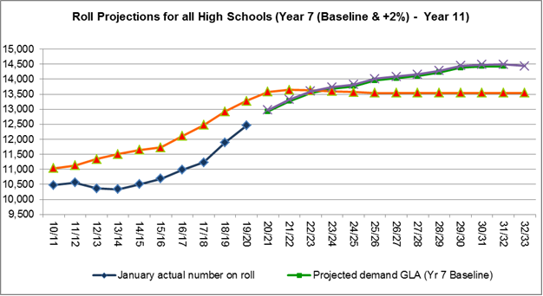
Source: SRP_borough_Spring2020_3_1_BPO2018_lowDomMig_2904201447
3.7 Year 7 Projections for High Schools

Table 20 and Chart 10 below show that Year 7 numbers on roll have been increasing for the last few years; from 1,932 in 2012/13 to 2,377 in 2016/17, but dropped slightly in 2017/18 to 2,347. However it increased again by 187 pupils in 2018/19 to 2,534 and by 136 pupils in 2019/20 to 2,670. Accordingly the GLA projections are suggesting a continued increase in the number of pupils from 2,657 (Baseline) and 2,710 (+2%) in 2020/21, to 2,830 (Baseline) and 2,887 (+2%) by 2032/33. Based on the baseline projections, a deficit of 1 FE is projected from 2022/23 onwards, with up to 5 extra forms of entry needed by 2027/28. Based on the +2% SRP a deficit of 2 FE is expected in 2021/22, increasing to 4 forms of entry in 2025/26 and continuing to increase quite significantly up to the end of the period.

Table 20: Secondary projections for Year 7 in all High Schools
Secondary projection area: All Schools
Year 7
Year | January actual number on roll | GLA projected demand Baseline | GLA projected demand +2% | Year 7 Places available* | Calculated FE Baseline | Additional FE required Baseline | Calculated FE +2% | Additional FE required +2% | Total Places to meet Baseline | Total Places to meet +2%
08/09 | 2,087
09/10 | 1,991
10/11 | 1,992
11/12 | 2,084
12/13 | 1,932
13/14 | 1,982
14/15 | 2,160
15/16 | 2,204
16/17 | 2,377
17/18 | 2,347
18/19 | 2,534
19/20 | 2,670
20/21 |  | 2,657 | 2,710 | 2,738* | 2.70 | 0 | 0.93 | 0 | 2,738 | 2,738
21/22 |  | 2,716 | 2,770 | 2,708** | -0.27 | 0 | -2.08 | 2 | 2,708 | 2,768
22/23 |  | 2,727 | 2,782 | 2,708 | -0.63 | 1 | -2.45 | 2 | 2,738 | 2,768
23/24 |  | 2,676 | 2,730 | 2,708 | 1.07 | 0 | -0.72 | 1 | 2,708 | 2,738
24/25 |  | 2,694 | 2,748 | 2,708 | 0.47 | 0 | -1.33 | 1 | 2,708 | 2,738
25/26 |  | 2,760 | 2,815 | 2,708 | -1.73 | 2 | -3.57 | 4 | 2,768 | 2,828
26/27 |  | 2,772 | 2,827 | 2,708 | -2.13 | 2 | -3.98 | 4 | 2,768 | 2,828
27/28 |  | 2,855 | 2,912 | 2,708 | -4.90 | 5 | -6.80 | 7 | 2,858 | 2,918
28/29 |  | 2,881 | 2,939 | 2,708 | -5.77 | 6 | -7.69 | 8 | 2,888 | 2,948
29/30 |  | 2,915 | 2,973 | 2,708 | -6.90 | 7 | -8.84 | 9 | 2,918 | 2,978
30/31 |  | 2,852 | 2,909 | 2,708 | -4.80 | 5 | -6.70 | 7 | 2,858 | 2,918
31/32 |  | 2,823 | 2,879 | 2,708 | -3.83 | 4 | -5.72 | 6 | 2,828 | 2,888
32/33 |  | 2,830 | 2,887 | 2,708 | -4.07 | 4 | -5.95 | 6 | 2,828 | 2,888
Source: SRP_borough_Spring2020_3_1_BPO2018_lowDomMig_2904201447
* Salvatorian College planned to have 180 places from September 2019 but this is no longer the case, which has been factored into the table above from 2019/20 onwards and Hatch End High is being rebuilt to a decreased PAN of 30 places permanently from 2020/21, which has been factored into the table above; **The Sacred Heart Language College will be reducing its PAN from 180 to 150 from September 2021.

Chart 10: Current NOR compared to roll projections and places available for all High schools, Year 7 (Baseline & +2%)
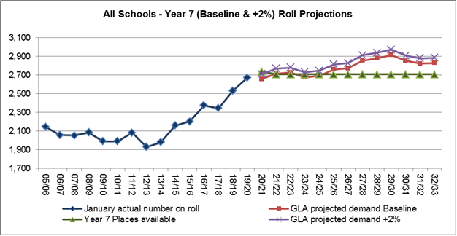
Source: SRP_borough_Spring2020_3_1_BPO2018_lowDomMig_2904201447

